Project Report
INTRODUCTION
YouTube allows users to upload videos, view them, rate them with likes and dislikes, share them, add videos to playlists, report, make comments on videos, and subscribe to other users. The slogan "Broadcast Yourself" used for several years and the reference to user profiles as "Channels" signifies the premise upon which the platform is based, of allowing anyone to operate a personal broadcasting station in resemblance to television with the extension of video on demand.
As such, the platform offers a wide variety of user-generated and corporate media videos. Available content includes video clips, TV show clips, music videos, short and documentary films, audio recordings, movie trailers, live streams, and other content such as video blogging, short original videos, and educational videos.
As of February 2017, there were more than 400 hours of content uploaded to YouTube each minute, and one billion hours of content being watched on YouTube every day. As of October 2020, YouTube is the second-most popular website in the world, behind Google, according to Alexa Internet. As of May 2019, more than 500 hours of video content are uploaded to YouTube every minute. Based on reported quarterly advertising revenue, YouTube is estimated to have US$15 billion in annual revenues.
YouTube has faced criticism over aspects of its operations, including its handling of copyrighted content contained within uploaded videos, its recommendation algorithms perpetuating videos that promote conspiracy theories and falsehoods hosting videos ostensibly targeting children but containing violent or sexually suggestive content involving popular charactersvideos of minors attracting pedophilic activities in their comment sections, and fluctuating policies on the types of content that is eligible to be monetized with advertising.

Problrms definitions & design Thinking
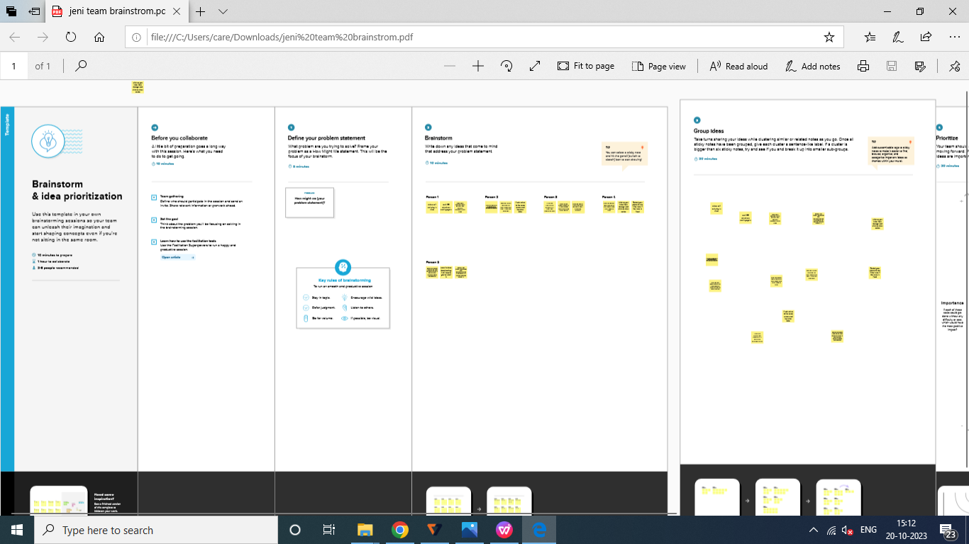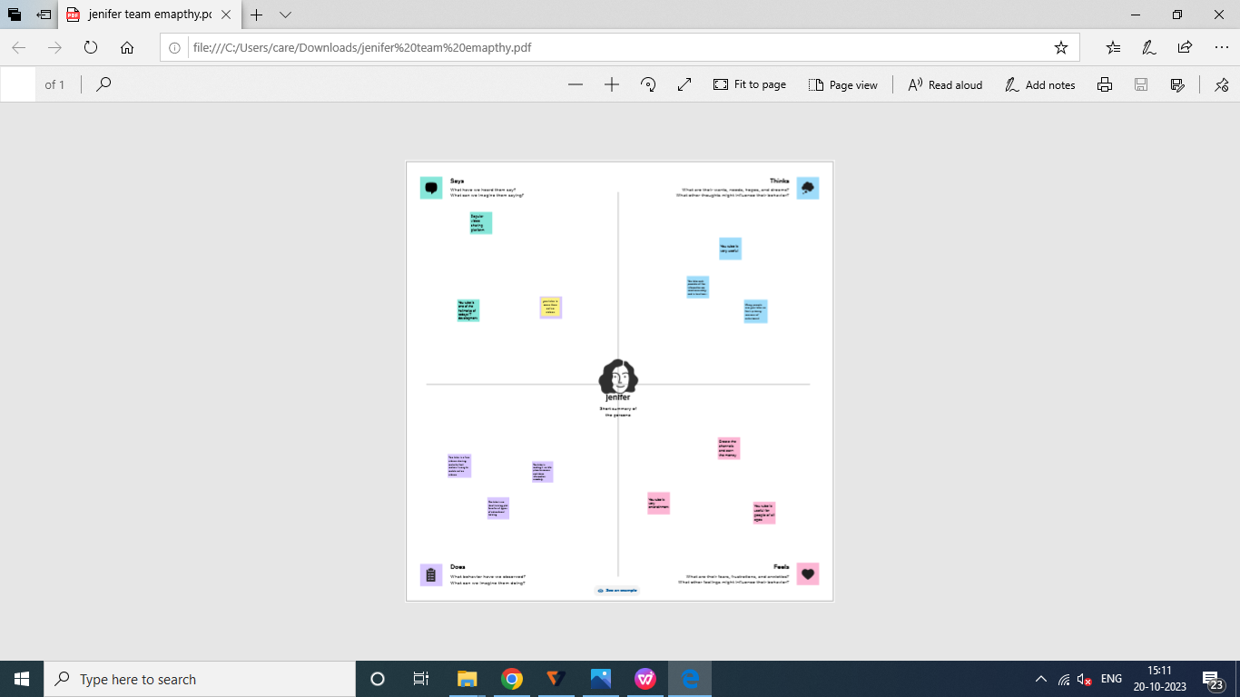

Result
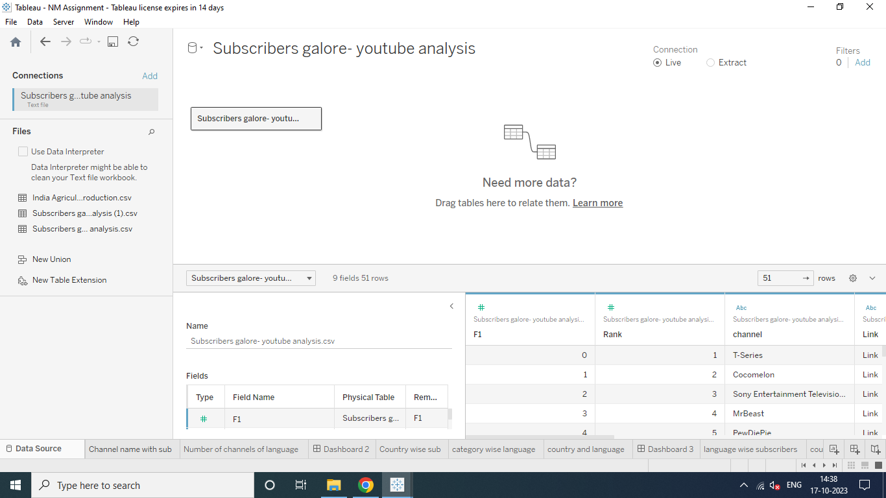

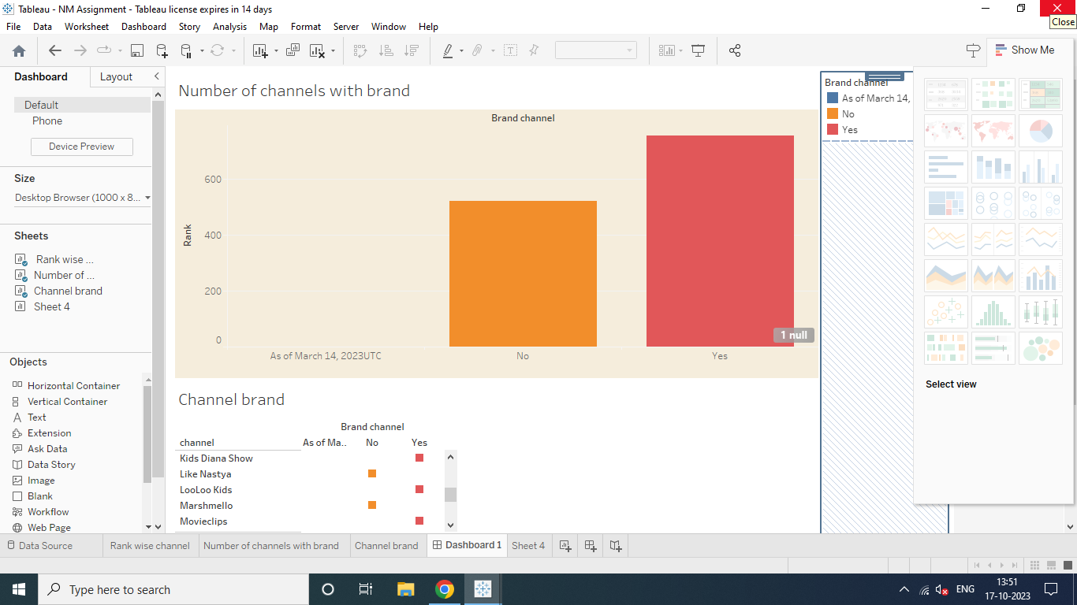

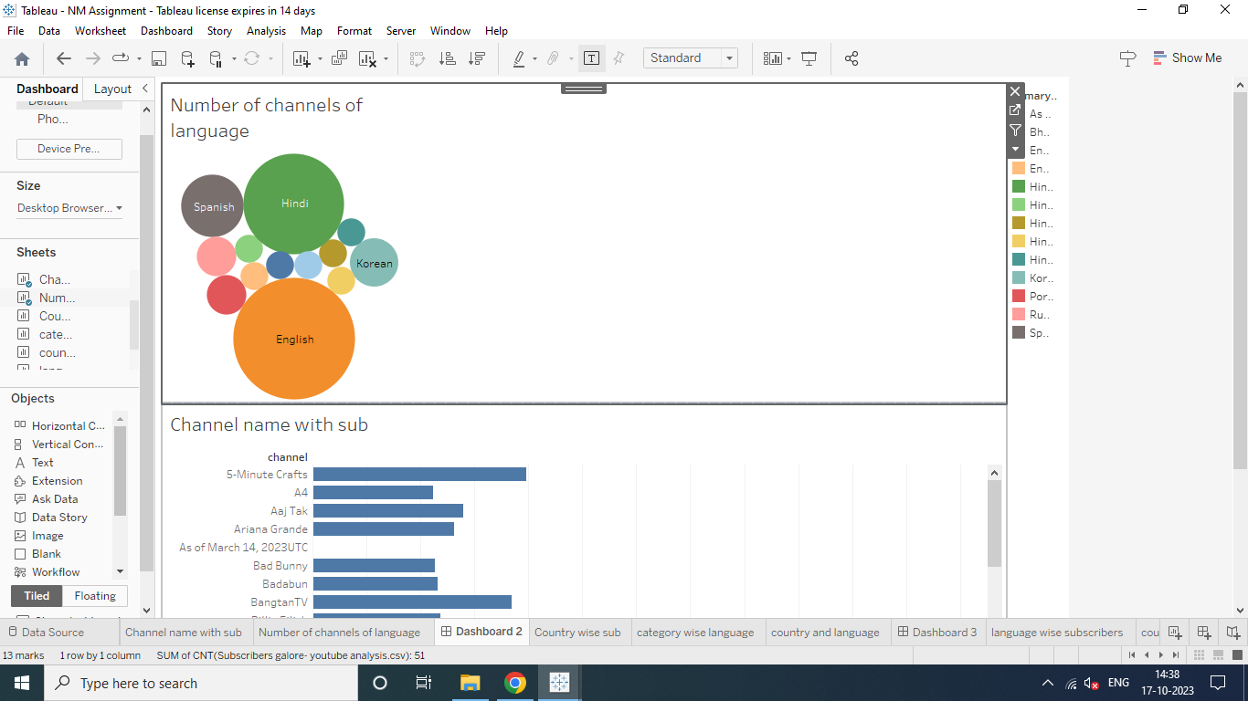

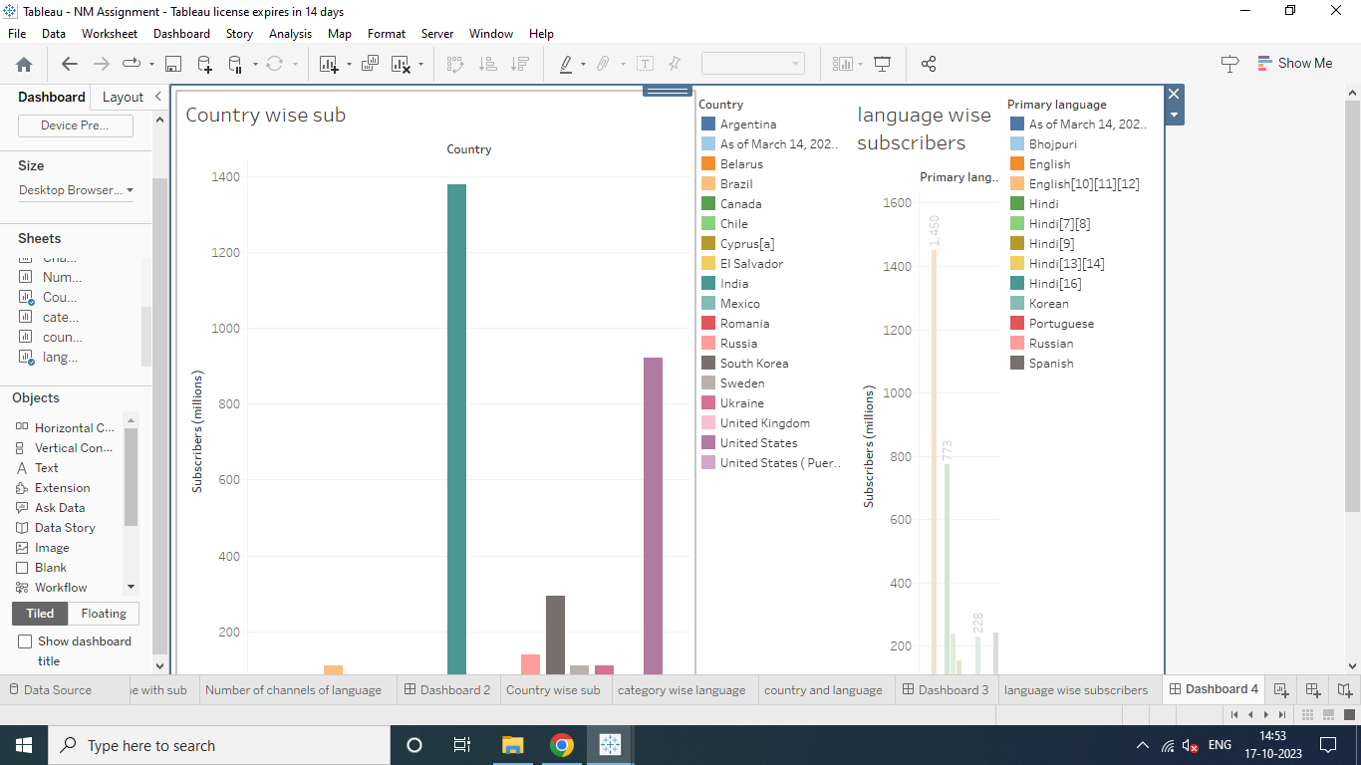

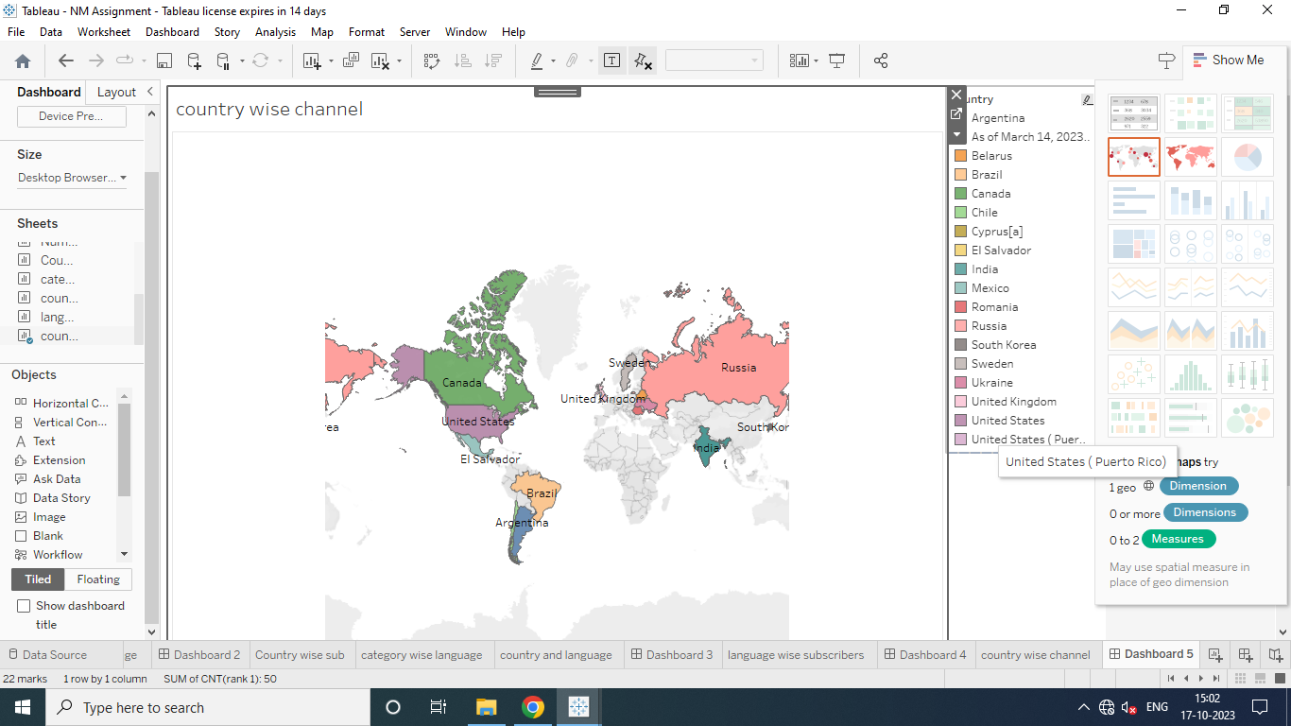

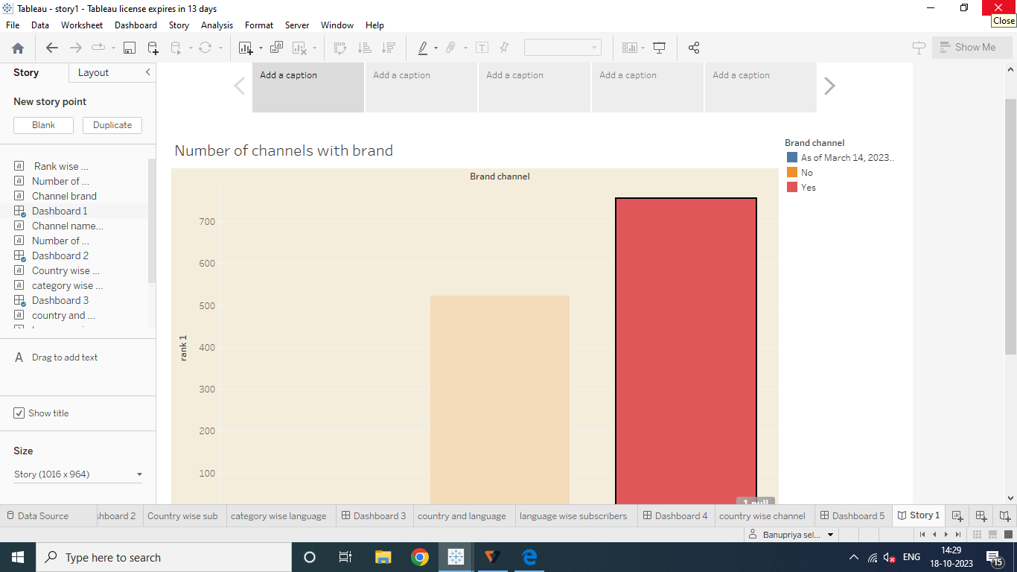

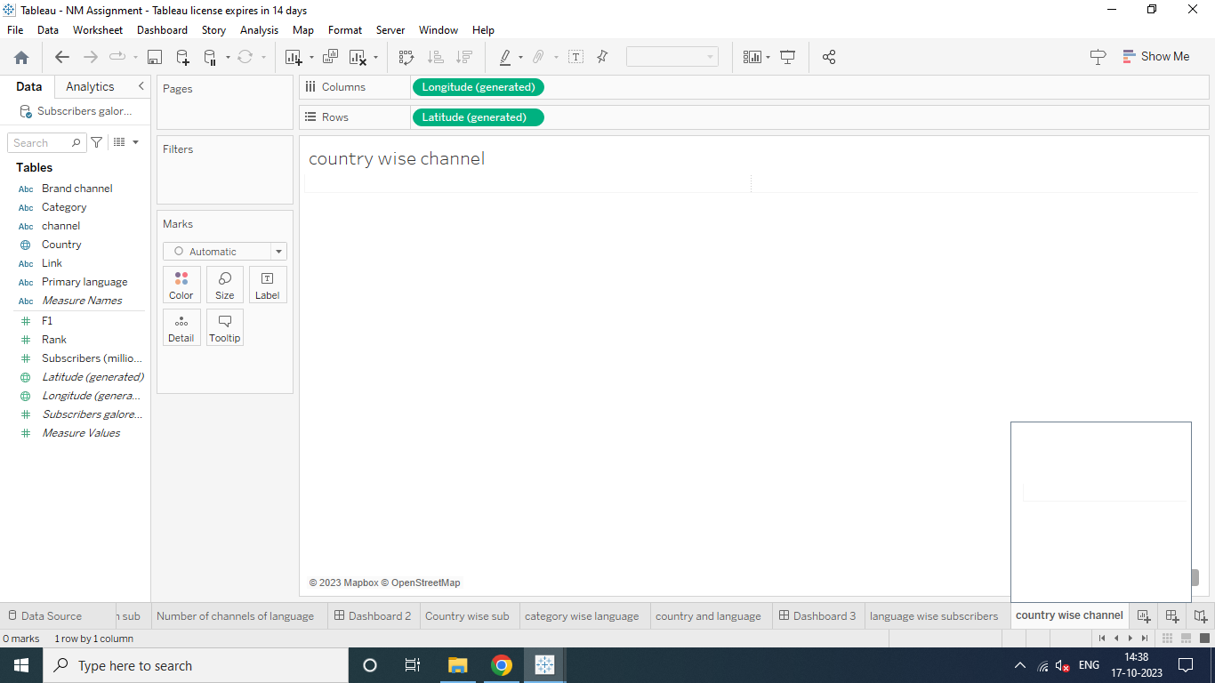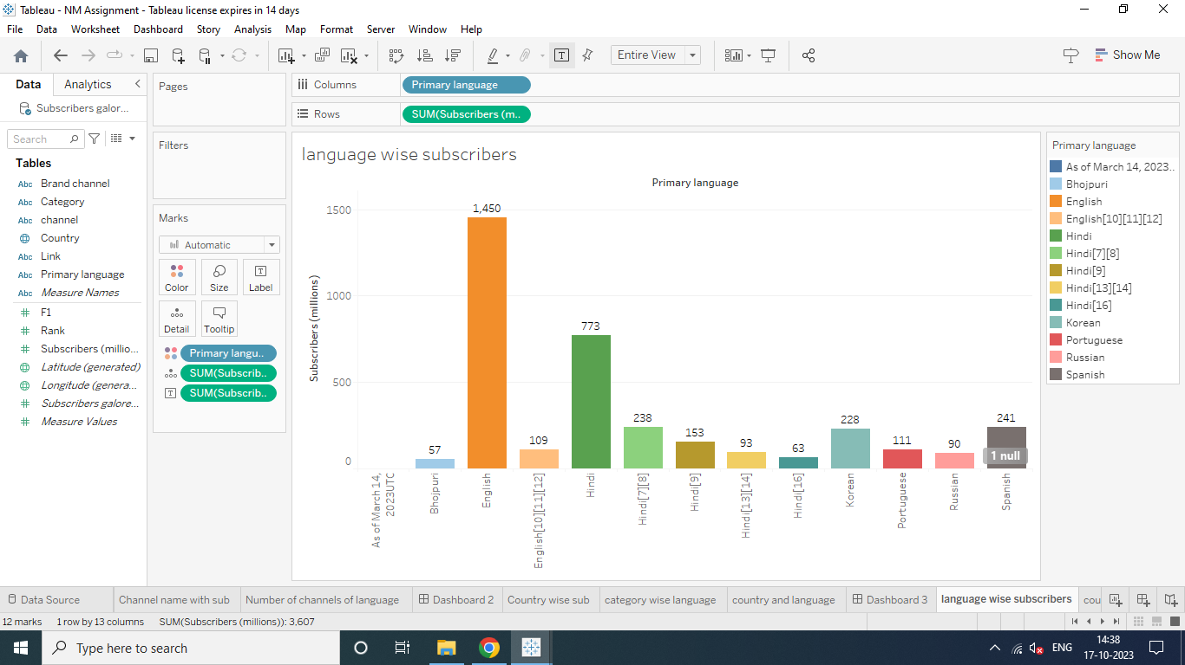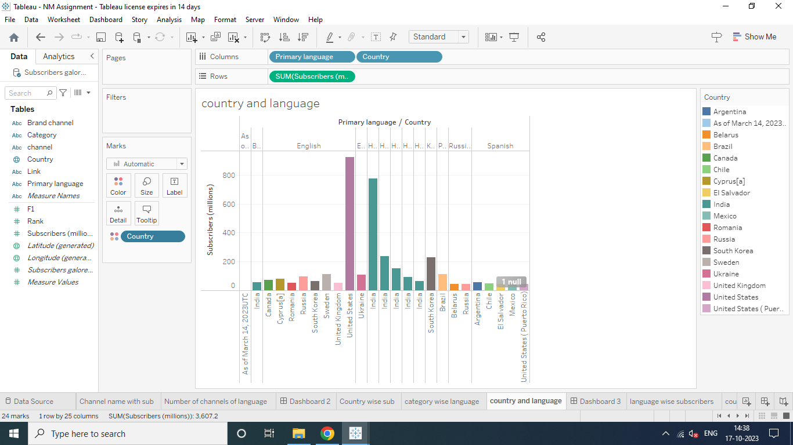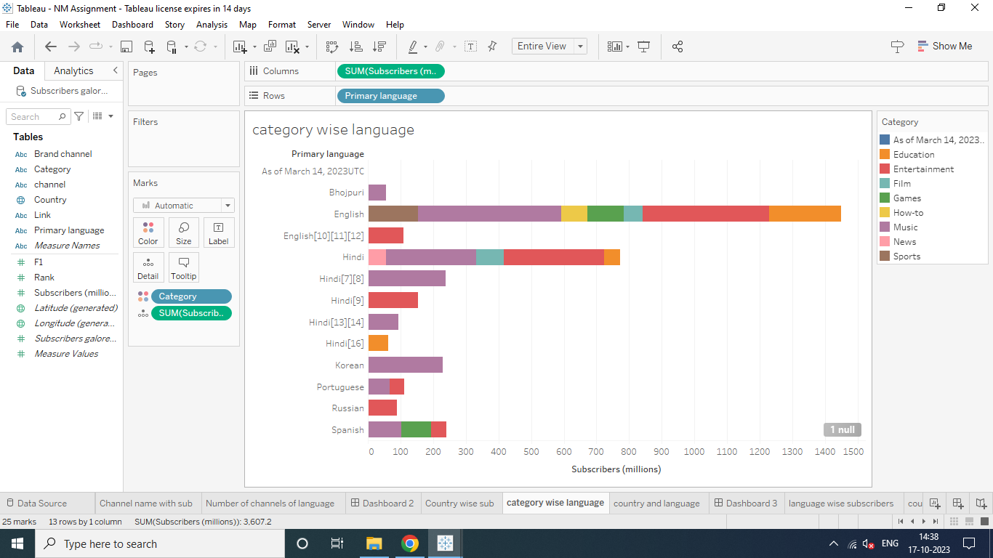
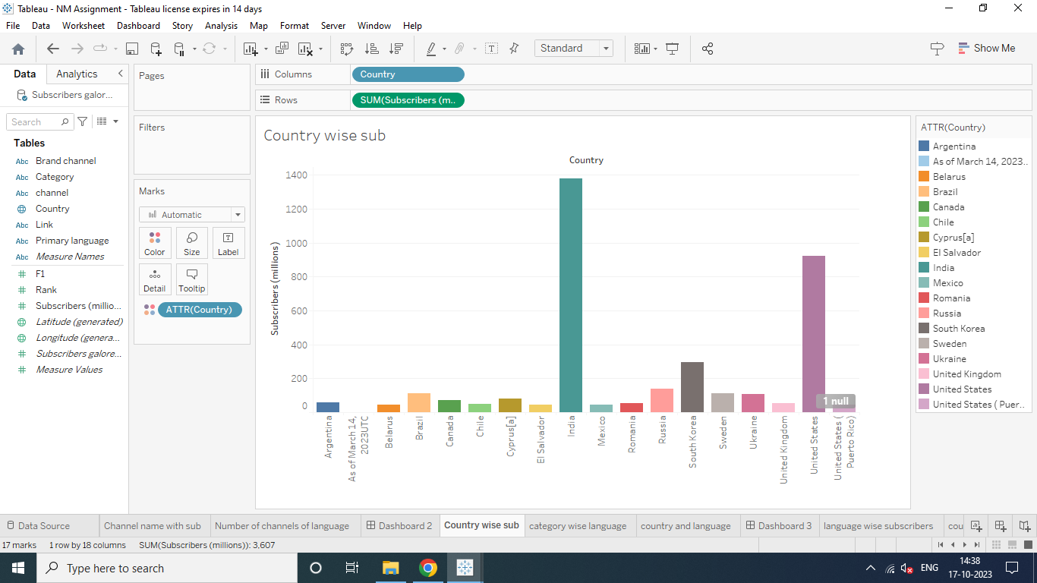
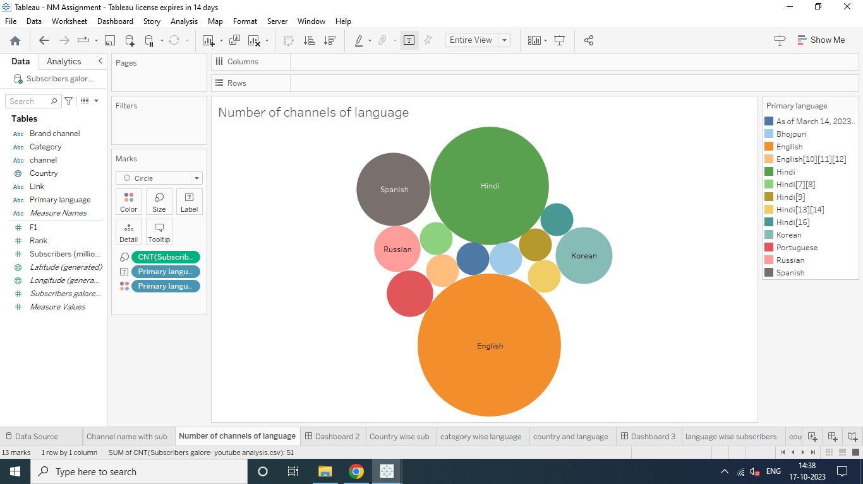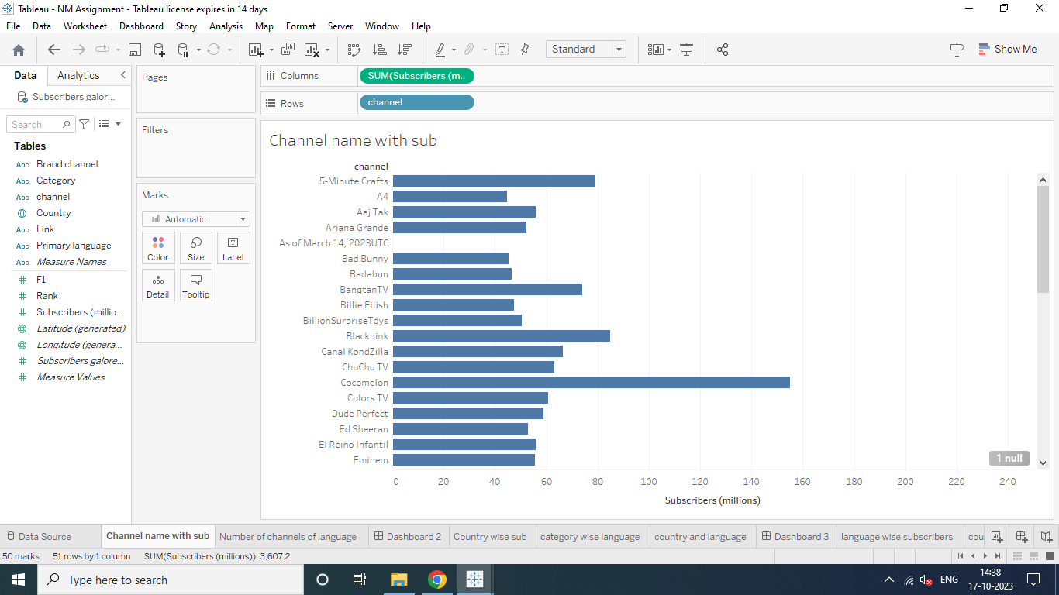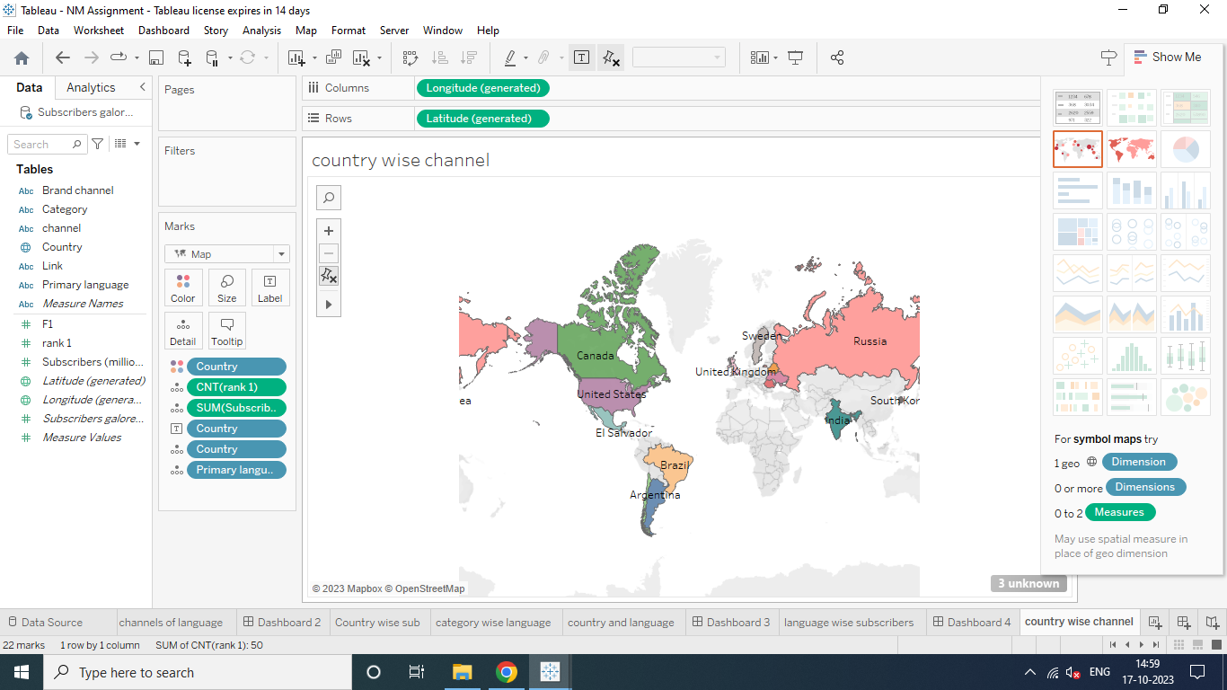

Youtube Advantages And Disadvantages
The pros and cons of YouTube for businesses and students, the audience, and the general public vary because the platform is used to serve a range of different causes. Let's take a look at the advantages of YouTube from various points of view.
1. YouTube as an information disseminating platform for students
It's the perfect place to learn and gain expertise. With online videos and "how to do" tricks, gaining knowledge is simple. In the process, YouTube is now the second largest source of information after Google. According to the most recent data, YouTube has around 2.3 billion active users as of 2021.
Millions of viewers watch YouTube videos daily, and more than 70 percent of YouTube watching is on mobile devices. There are many YouTube benefits for students in the automotive, IT engineering, financial and Medical fields. There is an expert YouTube channel for every area.
2. YouTube's user-friendliness
If you're interested in food, religion, culture, or parenting tips, there's a channel on YouTube that will offer online help. It's not just for professionals or pupils; YouTube is made for anyone to find what they enjoy. From pet lovers to homemakers, anyone can find content suitable to their interests. YouTube will keep the content informative and stimulating.
3. YouTube for Brand Promotion
YouTube videos have been an effective branding method for many businesses, especially during the lockdown. There are a lot of promotional videos from major business companies such as Redbull, shopping mode, Apple, BMW, Motorola, and many more.
With thousands of people using the platform, they are potential buyers too. Building a brand is the simplest method on the top platform. Millions of companies use this method, whether directly or through collaboration with influencers.
4. YouTube benefits talented people
If you think that you're specializing in something, then you are worthy of attention. The time is right to launch your own channel and be awestruck by viewers from all over the world. DIY and craft projects are searched for constantly. YouTubers with millions of subscribers show off their expertise by creating stunning projects, whether it's woodworking or Scotty Kilmer's automotive techniques. All you need to do is be focused on your passions and then roll out your ideas in videos that demonstrate how your work is beneficial in everyday life.
5. Easy Earning is at the very top of the list of YouTube benefits for Vloggers
Everyone is interested in the opportunity to turn their passion into a profit. This is exactly the kind of thing Youtube can offer any creator who has viewers. If your channel is populated with viewers and interesting content, you'll benefit the most from a YouTube Channel.
You can make money through your YouTube channel after it has reached the point of eligibility. It's easy to upload your content on the platform, and you can handle it all on your own. It is not necessary to invest in expensive equipment or accessories.

Disadvantages of YouTube
Apart from the advantages and benefits, there are also some negative aspects of YouTube for both YouTubers and viewers. There have been numerous instances have been reported concerning content censorship because it is detrimental to students as well as society. The following elements can be attributed to the negatives of Youtube from various points of View-
1. Ads- a drawback of YouTube for the audience
There are some distinct disadvantages of watching YouTube videos, which include a lot of commercials. It is possible to skip your mainstream. However, you're often required to watch commercials lasting between 15 and 20 seconds. This isn't just a time-waster, but it can be irritating at times. Another issue that is associated with YouTube is that it requires you to pay a charge if you would like to view ads-free content.
2. A lot of distraction
The platform is updated with new content each minute, making it difficult to avoid engaging and interesting videos. When you begin viewing Youtube videos, you'll be able to continue watching more videos in the "Related Videos" section.
According to research done by the collective, the issue of distraction while driving can be a worldwide problem that kills and injures thousands of people each year. There are fatal outcomes of driving while being distracted by videos that depict a negative image of YouTube. Distraction is one of the most common disadvantages of YouTube for drivers, students, or even workers.
3. Obscenity- one of the biggest drawbacks that YouTube has
The kind of content that is uploaded on YouTube is largely in control today. The amount of people uploading videos has grown in the past five years, and it's becoming challenging for parents, as well as YouTube, to review the content. Since YouTube is a no-cost and accessible platform for anyone, children are attracted to watching videos with explicit language and obscenity.
The use of explicit images and words is common nowadays. This kind of content can be removed only when someone is notified about it. In general, YouTube acts faster against copyright issues that are reported. There are many negatives when the viewers are children as they are merely aware of how to report the issue.
4. Defamation and Bullying
It's a tool that helps the public notice you; untrustworthy people may use YouTube to harm other people's image in public. The public has begun to consider YouTube as a potential social media, particularly over the past five years.
However, YouTube also enables people to do socially interaction. While they communicate, any conversation which occurs may be considered cyber-bullying. The easiest method to reach someone on YouTube is via the comment area.
However, many users misuse the platform to spread hate and chaos via content, causing tension between users. This is even when Google requests that users be respectful in their comments.
5. Making money isn't that easy
You can sign up for a YouTube affiliate or partner program to earn. However, to be eligible for these programs, you'll need to have at minimum 1000 subscribers as well as 4,000 watching hours over the last twelve months. If you're unable to achieve this, it will come with more drawbacks to YouTube than benefits.
While it's an easy and efficient method of earning money, it won't be as if it's growing on trees. YouTube has an algorithm that will scrutinize and validate every channel's legitimacy before allowing it to be played. Therefore, if you decide to play in a way that is not legitimate, YouTube has the algorithm to catch such activities too.
YouTube is a very popular platform for the collection of all kinds of music, art, dance, education, and all sorts of videos. It has a variety of content ranging from kids’ videos, games, movies to financing and exam preparation videos to stand-up comedy videos and motivational videos. You name it and you can find it.
YouTube is also a platform using which you can earn as a content creator as there is an audience for all kinds of content you can create content of your liking and interest. YouTube is certainly seductive as a career. Access to a global audience and the alternative of pursuing your interests with creativity lets you explore yourself and experiment in all fields of your choice.

Conclusion
There are many positive aspects to keep in mind about YouTube in comparison to the negatives. By analyzing the positives and negatives of YouTube, it is possible to get an idea of the number of users who receive the information and what percentage of them are misleading. The whole thing is based on people's interests, which is the reason YouTube exists, and so do YouTube channels.
Future scope
YouTube is a very popular platform for the collection of all kinds of music, art, dance, education, and all sorts of videos. It has a variety of content ranging from kids’ videos, games, movies to financing and exam preparation videos to stand-up comedy videos and motivational videos. You name it and you can find it.
YouTube is also a platform using which you can earn as a content creator as there is an audience for all kinds of content you can create content of your liking and interest. YouTube is certainly seductive as a career. Access to a global audience and the alternative of pursuing your interests with creativity lets you explore yourself and experiment in all fields of your choice.

